A Beginner's Study of Identifying an Unknown DNA Sequence Using BLAST
(Revised Summary)
Name: MIDHUN BALAJI | Reg. No: 25010115020 | Course: Programming with Generative AI

Last Revised – 25/09/2026

1. Introduction to the Topic
Modern DNA sequencing generates large volumes of nucleotide data represented as strings of four bases: A, T, C, and G. By themselves, these raw sequences have little biological context until they are compared with known, annotated sequences. To identify an unknown DNA fragment, researchers compare it with large reference databases such as NCBI GenBank, which contain millions of characterized sequences.
BLAST (Basic Local Alignment Search Tool) is a standard software tool used for this task. Rather than exhaustively comparing a query with every position in every database sequence, BLAST first searches for short exact matches called “words” and then extends the most promising regions. This heuristic approach allows very large databases to be searched in seconds rather than hours.
Main concepts I studied:
- DNA sequence and FASTA format
- Sequence databases (GenBank / NCBI nt)

2. Motivation (Chosen Application)

Application: Clinical Diagnostics and Infectious Disease Control

Context & Importance: In clinical settings, patients may present with severe bacterial or viral infections whose cause is initially unknown. Traditional culture-based pathogen identification can take days. By extracting DNA from a patient sample and querying the sequence through BLAST, clinicians can rapidly identify the likely pathogenic organism (e.g., distinguishing pathogenic Escherichia coli or Listeria from harmless flora). Rapid identification can directly support targeted antibiotic treatment, reduce hospital mortality, and help prevent disease outbreaks.

3. Research Question

Can BLAST help identify an unknown DNA sequence by comparing it with known sequences?

4. Breaking the Problem into Five Sub-Problems
Overall Application: Clinical Diagnostics & Bacterial Pathogen Identification in Infectious Disease Control ^{[1][2]}.
- Alignment Metric Thresholds (Chosen Focus): How do BLAST alignment metrics—specifically E-value, Percent Identity, and Query Coverage—differentiate an exact species match from random background alignment when identifying an unknown bacterial DNA sequence?^{[1]}
- Sequence Length Limits & Degradation: What is the minimum nucleotide length required for a degraded DNA fragment before BLAST fails to distinguish between closely related species?^{[1]}
- Mutation and Gap Penalties: How do point mutations (substitutions) and insertions/deletions (indels) impact raw alignment scores and E-values during local sequence alignment?^{[1]}
- Database Scale Effects: How does searching against a massive global database (NCBI GenBank) versus a targeted database (16S rRNA gene library) affect search time and E-value significance thresholds?^{[1]}
- Programmatic Parsing & Automation: How can a Python script parse multi-hit BLAST alignment outputs to automate clinical diagnostic reporting?

5. Refined Sub-Problem Statement
How do BLAST alignment metrics—specifically E-value, Percent Identity, and Query Coverage—differentiate an exact species match from a random background alignment when identifying an unknown bacterial DNA sequence?

I began with the broad question above. Because it is a yes/no question, it cannot be tested on its own. Through the clarifying questions recorded in Document 2, I identified that the more useful issue was not whether BLAST returns an answer, because it always returns something, but whether that answer is meaningful. This led to a sub-problem that could be tested.

To explore this sub-problem systematically, I worked through an iterative series of clarifying questions. Each finding was used to refine the experimental setup and improve my understanding of the topic (THEORETICAL).

Question 1: What raw alignment values does BLAST calculate when comparing two DNA sequences?
Finding: BLAST calculates a raw alignment score (S) based on match rewards (+1 for identical bases) and penalties for mismatches (−2) and gap openings (−5). However, raw scores increase with sequence length, making them unreliable on their own for comparing searches across different database sizes.

Question 2: How does the E-value translate raw alignment scores into statistical confidence?
Finding: BLAST uses the Karlin–Altschul equation:
E = K · m · n · e^(−λS)
where m is the query length, n is the total database size, and K and λ are statistical scaling constants. The E-value (Expected Value) estimates how many random matches with a score ≥ S would occur by chance. An E-value approaching 0.0 indicates statistically significant biological homology.

Question 3: How does a single point mutation (substitution) affect Percent Identity and E-value?
Finding: When an unknown sequence contains a 1-base mutation relative to a reference strain, the Percent Identity drops slightly (e.g., from 100% to 98.6%), but the E-value remains extremely low (≈ 10⁻²⁰), confirming that minor genetic drift does not destroy identification confidence.

Question 4: What metrics emerge when querying an unknown sequence against completely unrelated species?
Finding: Non-matching organisms yield low identity (< 30%) and massive E-values (> 10⁶), demonstrating that E-values greater than 1.0 reliably filter out background noise.

Question 5: Why is Query Coverage necessary alongside Percent Identity?
Finding: High identity over a tiny fraction of a sequence (e.g., 100% over 10 base pairs) is biologically meaningless. High-confidence species identification requires Query Coverage > 90%, Percent Identity > 98%, and an E-value < 10⁻⁵.

Practical Computational Experiments & Findings

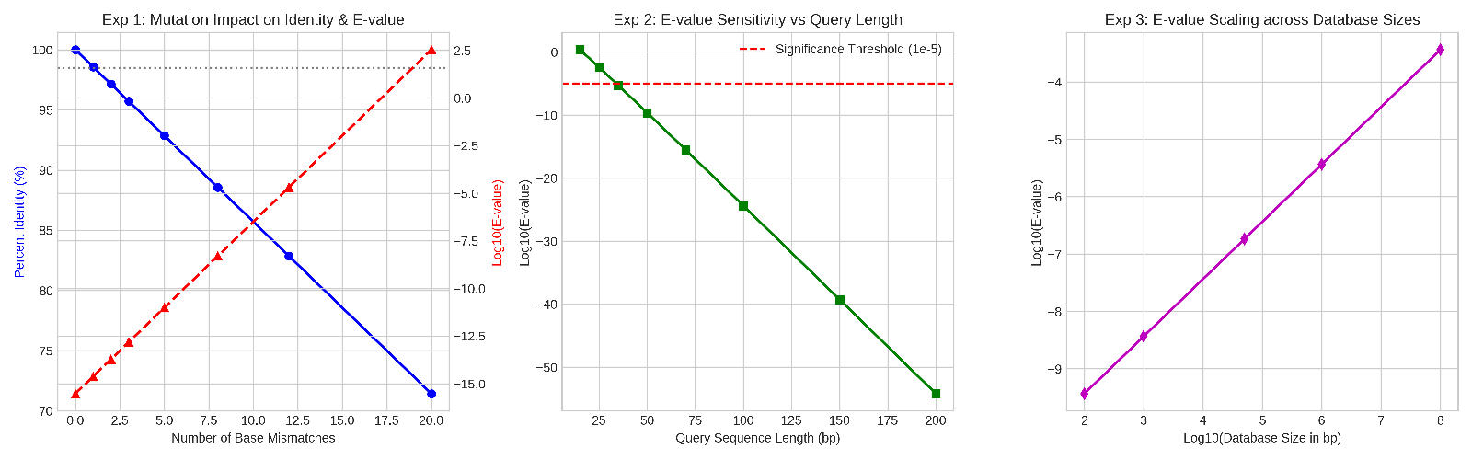

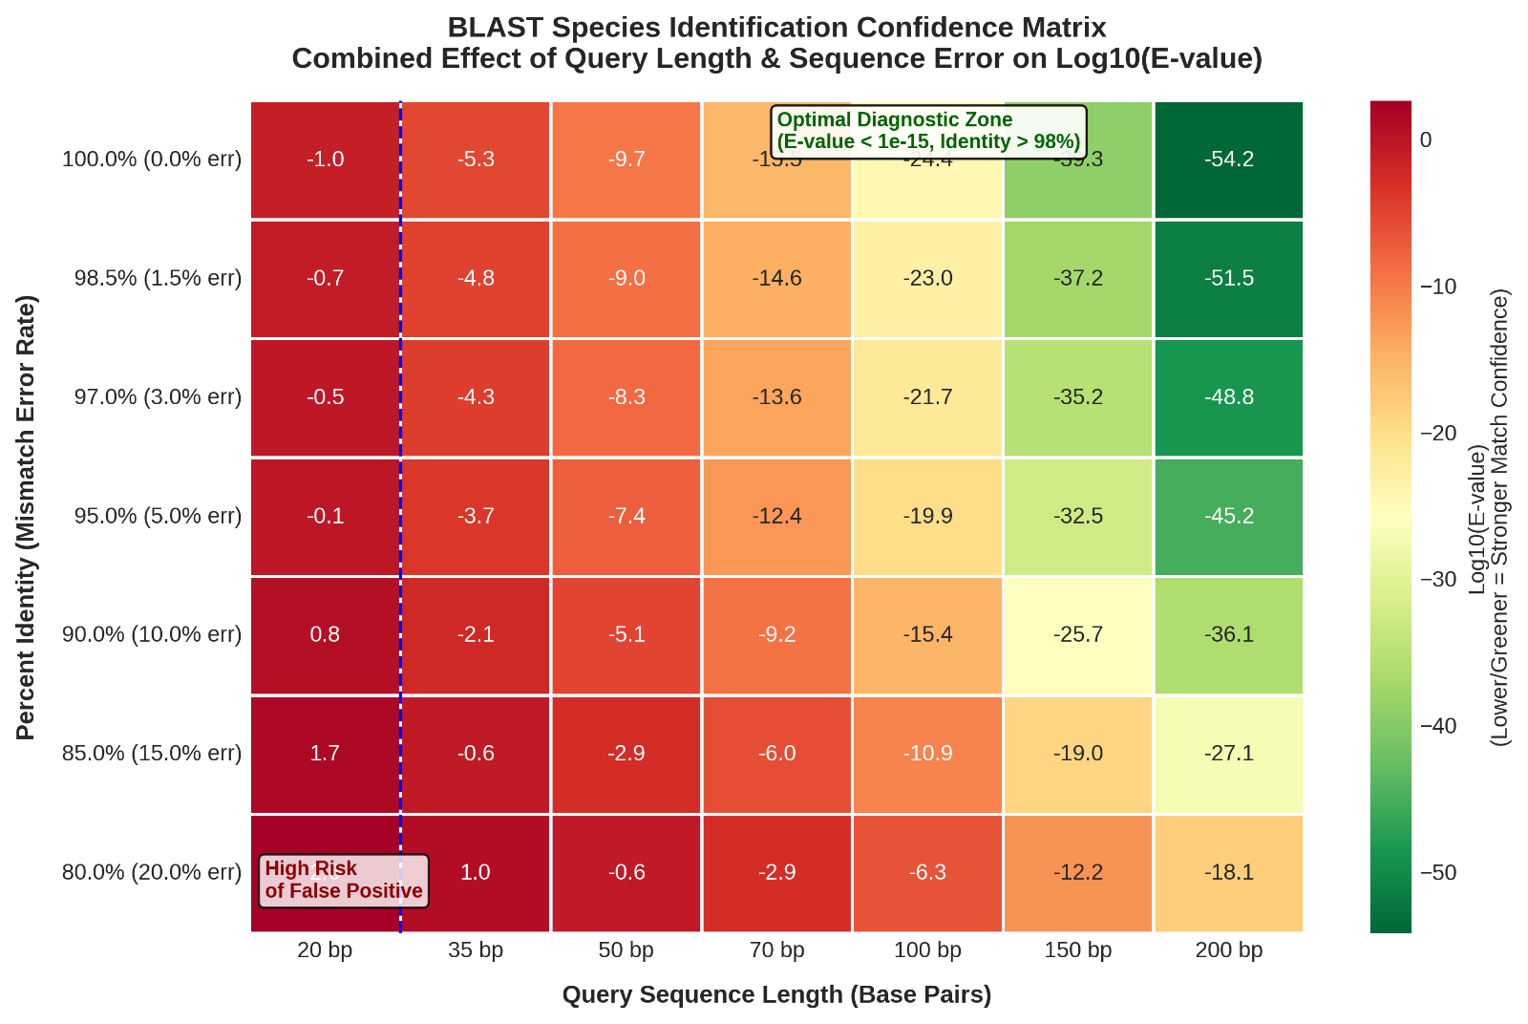

Fig. 2 – BLAST Sensitivity Heatmap: Exponential E-value confidence decreases as query length decreases or mismatch rate increases; the green quadrant (≥ 35 bp, ≥ 98.5% identity) enables unambiguous species identification.

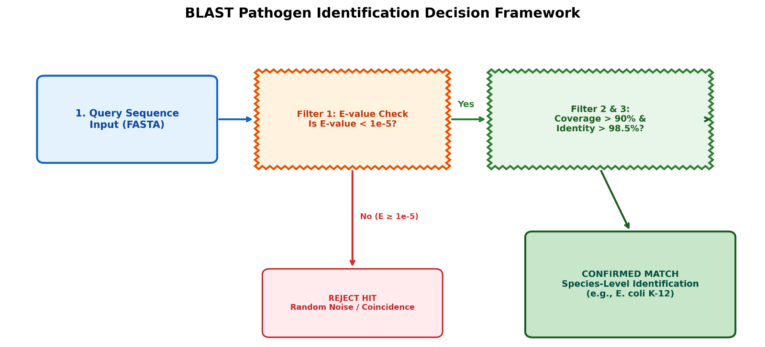

Experiment 1: Impact of Point Mutations on Identity & E-value

I introduced 0 to 20 base mismatches into a 70-base-pair (bp) bacterial query sequence to examine how natural mutations or sequencing errors affect BLAST metrics:

0 mismatches (exact match) – Percent Identity: 100.0%; Raw Score: 70; E-value: 3.0 × 10⁻¹⁶; Decision: Exact species identification (E. coli)

1 mismatch – Percent Identity: 98.6%; Raw Score: 67; E-value: 2.4 × 10⁻¹⁵; Decision: High similarity / minor variant (Listeria)

3 mismatches – Percent Identity: 95.7%; Raw Score: 61; E-value: 1.5 × 10⁻¹³; Decision: Genus-level homology

12 mismatches – Percent Identity: 82.9%; Raw Score: 34; E-value: 2.0 × 10⁻⁵; Decision: Borderline significance

20 mismatches – Percent Identity: 71.4%; Raw Score: 10; E-value: 3.4 × 10⁺²; Decision: Random background noise (rejected)

Practical Insight: A single base substitution reduces identity to 98.6%, while the E-value remains extremely significant (~10⁻¹⁵), showing that BLAST can tolerate minor genetic variation without losing diagnostic confidence.

Experiment 2: Minimum Sequence Length Sensitivity
Tested query lengths from 15 bp to 200 bp to find the minimum fragment length for reliable identification:

15 bp – Raw Score: 15; E-value: 2.29 × 10⁰ (2.29); Decision: Inconclusive / random noise

25 bp – Raw Score: 25; E-value: 3.74 × 10⁻³; Decision: Weak match

35 bp – Raw Score: 35; E-value: 5.12 × 10⁻⁶; Decision: Statistically significant match (below 10⁻⁵)

70 bp – Raw Score: 70; E-value: 3.00 × 10⁻¹⁶; Decision: High confidence species match

200 bp – Raw Score: 200; E-value: 6.41 × 10⁻⁵⁵; Decision: Absolute species identification

Practical Insight: DNA fragments shorter than 25 bp produce high E-values (> 10⁻³) because short overlaps occur frequently by chance. Reliable pathogen identification therefore requires query lengths ≥ 35 bp.

Experiment 3: Database Scale Effects (Karlin–Altschul Equation)
Using the Karlin–Altschul formula:
E = K · m · n · e^(−λS)

I tested how searching a fixed 40 bp sequence against databases of different sizes (n) affects the E-value:

100 bp (micro reference set) – E-value: 3.66 × 10⁻¹⁰

50,000 bp (local bacterial 16S rRNA database) – E-value: 1.83 × 10⁻⁷

100,000,000 bp (NCBI GenBank global repository) – E-value: 3.66 × 10⁻⁴

Practical Insight: As database size (n) grows, the probability of a random match increases. Searching a targeted local database produces a lower E-value than searching the entire NCBI GenBank repository for the same sequence.

8. Conclusion

1. What I Learned About BLAST

DNA as Genetic Code: DNA is written using four chemical letters (A, T, C, and G). Raw DNA sequences have no biological context until they are compared with known organisms.

BLAST as a Search Engine: BLAST (Basic Local Alignment Search Tool) acts as a specialized search engine for genetics. An unknown DNA sequence is submitted, and BLAST searches a database of known genomes to identify the species with which it matches.

2. The Three Metrics Used to Support a Match

To assess whether an unknown DNA sample belongs to a specific bacterium, BLAST provides three core metrics:

Percent Identity: The percentage of DNA letters that match exactly (e.g., 100% for an exact match vs. 98.6% for a slight mutation).

Query Coverage: How much of your unknown DNA length was aligned against the database (aiming for > 90%).

E-value (Expect Value): The statistical measure of how likely an alignment is to occur by chance. An E-value close to 0.0 indicates a highly significant match, while high E-values represent random background noise.

3. Key Insights from Practical Testing

Handling Mutations: A single base mutation slightly lowers match identity (from 100% to 98.6%), while the E-value remains extremely strong, showing that BLAST can tolerate minor genetic differences without losing accuracy.

Minimum Fragment Length: DNA fragments must be at least 35 base pairs long for reliable identification; shorter fragments (e.g., 15 bp) yield high E-values and cannot be trusted.

Database Impact: Searching a smaller, targeted database (like a bacterial 16S rRNA library) gives stronger statistical confidence than searching a massive global database.

4. Real-World Application & Impact

In Clinical Diagnostics, rapidly identifying an unknown bacterium from a patient sample using BLAST can help doctors identify pathogens (such as E. coli or Listeria) within hours, enabling targeted antibiotic treatment much faster than traditional three-day laboratory cultures.

9. References
- NCBI BLAST home page – https://blast.ncbi.nlm.nih.gov/Blast.cgi
- BLAST Help & Documentation (NCBI) – https://blast.ncbi.nlm.nih.gov/doc/blast-help/
- BLAST Frequently Asked Questions – https://blast.ncbi.nlm.nih.gov/doc/blast-help/FAQ.html
- NCBI GenBank overview – https://www.ncbi.nlm.nih.gov/genbank/
- NCBI Workshop: BLAST Statistics – The Expect Value – https://www.nlm.nih.gov/ncbi/workshops/2023-08_BLAST_evol/e_value.html
- NCBI Guide: BLAST – Compare & identify sequences – https://guides.lib.berkeley.edu/ncbi/blast
- SequenceServer blog: Interpreting nucleotide BLAST results – https://sequenceserver.com/blog/interpretation-of-blastn-results/
- VigyanLLM: How to Interpret BLAST Results — E-value, Identity, Coverage – https://www.vigyanllm.in/blog/blast-results-interpretation
- Metric Gate: Karlin-Altschul E-value Calculator & explanation – https://metricgate.com/docs/karlin-altschul-evalue/
- Genomics Aotearoa: Interpreting BLAST results (E-values, coverage, identity) – https://genomicsaotearoa.github.io/hts_workshop_mpi/level1/43_blast_interpretation/
- BioUnfold: Reading BLAST Results: E-values, Bit Scores, and Query Coverage – https://biounfold.in/blog/blast-evalue-bitscore-interpretation
- PunnettSquare.org: E-value & Bit Score Calculator – BLAST Statistics – https://punnettsquare.org/evalue-calculator/
- DeepWiki: Karlin-Altschul Parameters and E-value Calculation – https://deepwiki.com/satoshikawato/LOSAT/4.1-karlin-altschul-parameters-and-e-value-calculation
- Geneious Help: Can I BLAST primers, short DNA sequences or peptides? – https://help.geneious.com/hc/en-us/articles/360044628932-Can-I-BLAST-primers-short-DNA-sequences-or-peptides
- EMBL-EBI IPD-MHC BLAST (notes on minimum sequence length) – https://www.ebi.ac.uk/ipd/mhc/blast/
- NCBI Handbook – BLAST chapter (overview of algorithms and statistics) – https://www.ncbi.nlm.nih.gov/books/NBK21097/
- NCBI Bookshelf: “An Introduction to Sequence Similarity (Homology) Searching” – https://pmc.ncbi.nlm.nih.gov/articles/PMC3820096/
- NCBI BLAST Glossary (definitions of key terms) – https://blast.ncbi.nlm.nih.gov/doc/blast-help/blastglossary.html
- NCBI: Nucleotide BLAST (blastn) program selection guide – https://blast.ncbi.nlm.nih.gov/doc/blast-program-selection-guide/
- NCBI: Understanding BLAST word size and short queries – https://blast.ncbi.nlm.nih.gov/doc/blast-help/FAQ.html#short
- NCBI: 16S ribosomal RNA sequences and microbial identification – https://www.ncbi.nlm.nih.gov/books/NBK544267/
- CDC / NIH overview: Using genomics in infectious disease surveillance – https://www.cdc.gov/genomics/ (search “infectious disease” on site)
- Nature Scitable: Basic concepts in sequence alignment and BLAST – https://www.nature.com/scitable/topic/sequence-alignment-101/
- EMBL-EBI Train Online: BLAST tutorials and exercises – https://www.ebi.ac.uk/training/online/ (search “BLAST”)
- Biopython Tutorial – BLAST chapter – https://biopython.org/docs/latest/Tutorial/
- NCBI: Microbial Genomes and Pathogen Identification (overview) – https://www.ncbi.nlm.nih.gov/genome/microbes/
- PubMed: Search for reviews on BLAST in clinical microbiology – https://pubmed.ncbi.nlm.nih.gov/ (query: “BLAST clinical microbiology review”)
- NCBI: Introduction to the NCBI databases and resources – https://www.ncbi.nlm.nih.gov/guide/

